1. IMAGE TO BIT STRING

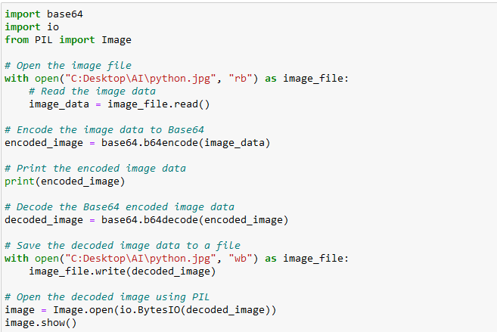

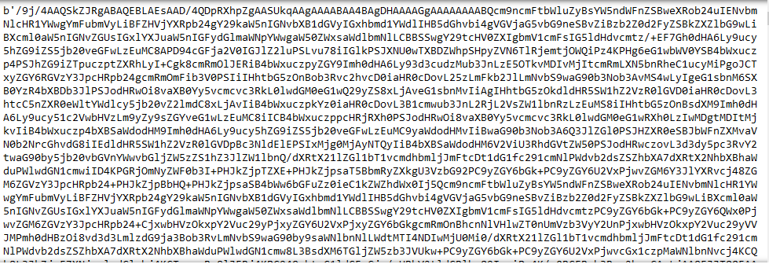

2.BITSTRING TO IMAGE(IMAGE AFTER DECODING)

